# Translation / DNA Translation:

Translation is the process of translating the sequence of a messenger RNA (mRNA) molecule to a sequence of amino acids during protein synthesis. The genetic code describes the relationship between the sequence of base pairs in a gene and the corresponding amino acid sequence that it encodes. In the cell cytoplasm, the ribosome reads the sequence of the mRNA in groups of three bases to assemble the protein. Here is a more complete definition of translation

The mRNA formed in transcription is transported out of the nucleus, into the cytoplasm, to the ribosome (the cell's protein synthesis factory). Here, it directs protein synthesis. Messenger RNA is not directly involved in protein synthesis − transfer RNA (tRNA) is required for this. The process by which mRNA directs protein synthesis with the assistance of tRNA is called *translation*.

**Stages of translation**

## Introduction

Ever wonder how antibiotics kill bacteria—for instance, when you have a sinus infection? Different antibiotics work in different ways, but some of them attack the very heart of a bacterial cell's internal operations: they knock out the cell's ability to make proteins.

To use a little molecular biology vocab, these antibiotics block **translation**. In the process of translation, a cell reads information from a molecule called a messenger RNA (mRNA) and uses this information to build a protein. Translation is happening constantly in a normal bacterial cell, just like it is in most of the cells of your body, and it's key to keeping you (and your infecting bacteria!) alive.

When you take certain kinds of antibiotics, such as erythromycin, the antibiotic—which is just a type of small molecule—will latch onto key translation molecules inside the bacterial cell and keep them from working. With no way to make proteins, bacterial cells will stop functioning and, eventually, die. That's why infections clear up when they're treated with the antibiotic.

So, translation is pretty important: cells need it to stay alive, and understanding how it works (so we can shut it down with antibiotics) can save us from bacterial infections. Here, we'll take a closer look at how translation happens, from the first step to the final product.

## Translation: The big picture

**Translation** involves “decoding” a messenger RNA (mRNA) and using its information to build a **polypeptide**, or chain of amino acids. A polypeptide is basically just a protein, except that some big proteins are made up of several polypeptide chains, not just one.

### The genetic code

In an mRNA, the instructions for building a polypeptide come in groups of three nucleotides called **codons**. Here are some key features of codons to keep in mind as we move forward:

* There are 616161 different codons for amino acids
* Three “stop” codons mark the polypeptide as finished
* One codon, AUG, is a “start” signal to kick off translation (it also specifies the amino acid methionine)

These relationships between mRNA codons and amino acids are known as the **genetic code** (learn more in the [genetic code](https://www.khanacademy.org/science/biology/gene-expression-central-dogma/central-dogma-transcription/a/the-genetic-code-discovery-and-properties) article).

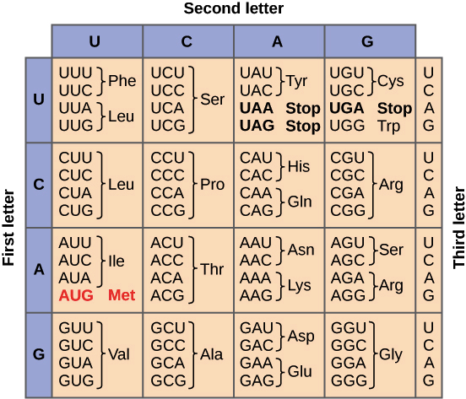

Genetic code table. Each three-letter sequence of mRNA nucleotides corresponds to a specific amino acid, or to a stop codon. UGA, UAA, and UAG are stop codons. AUG is the codon for methionine, and is also the start codon.

### Codons to amino acids

In translation, the codons of an mRNA are read in order (from the 5' end to the 3' end) by molecules called **transfer RNAs**, or **tRNAs**.

Each tRNA has an **anticodon**, a set of three nucleotides that binds to a matching mRNA codon through base pairing. The other end of the tRNA carries the amino acid that's specified by the codon.

[[What are 5', 3', and base pairing?]](javascript:void(0))

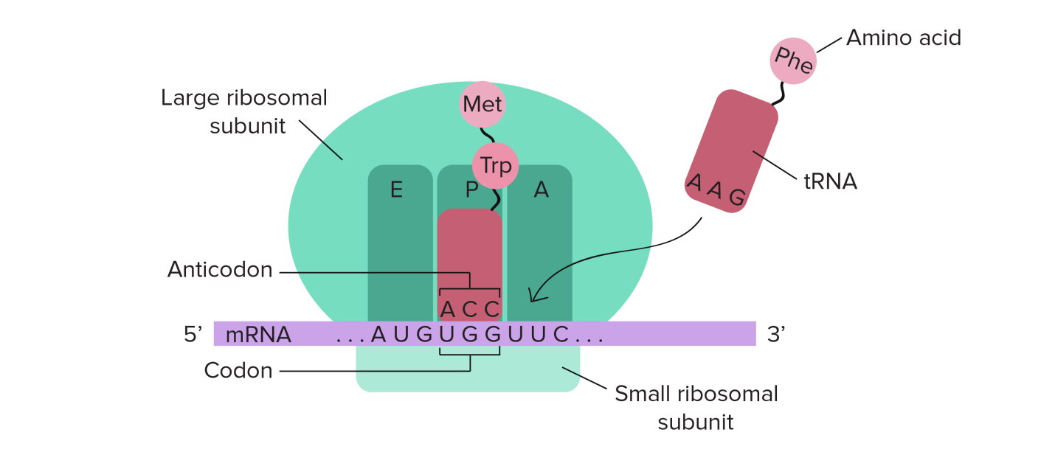

tRNAs bind to mRNAs inside of a protein-and-RNA structure called the**ribosome**. As tRNAs enter slots in the ribosome and bind to codons, their amino acids are linked to the growing polypeptide chain in a chemical reaction. The end result is a polypeptide whose amino acid sequence mirrors the sequence of codons in the mRNA.



## Translation: Beginning, middle, and end

A book or movie has three basic parts: a beginning, middle, and end. Translation has pretty much the same three parts, but they have slightly fancier names: initiation, elongation, and translation.

* **Initiation** ("beginning"): in this stage, the ribosome gets together with the mRNA and the first tRNA so translation can begin.
* **Elongation** ("middle"): in this stage, amino acids are brought to the ribosome by tRNAs and linked together to form a chain.
* **Termination** ("end"): in the last stage, the finished polypeptide is released to go and do its job in the cell.

## Stage 1: Initiation

In order for translation to start, we need a few key ingredients. These include:

* A ribosome (which comes in two pieces, large and small)
* An mRNA to give instructions for the protein we'll build
* The tRNA carrying the first amino acid in the protein, which is almost always methionine (Met)

Initiation is all about bringing these ingredients together in the right way so that translation can begin. When assembled, they form what's called the **initiation complex**, and translation is good to go!

In humans and other eukaryotes (like plants and fungi), the tRNA carrying methionine first attaches to the small ribosomal subunit. Together, they attach to the 5' end of the mRNA by recognizing the 5' GTP cap that is added during processing in the nucleus. Then, they "walk" along the mRNA in the 3' direction, stopping only when they reach the start codon (often, but not always, the first AUG).

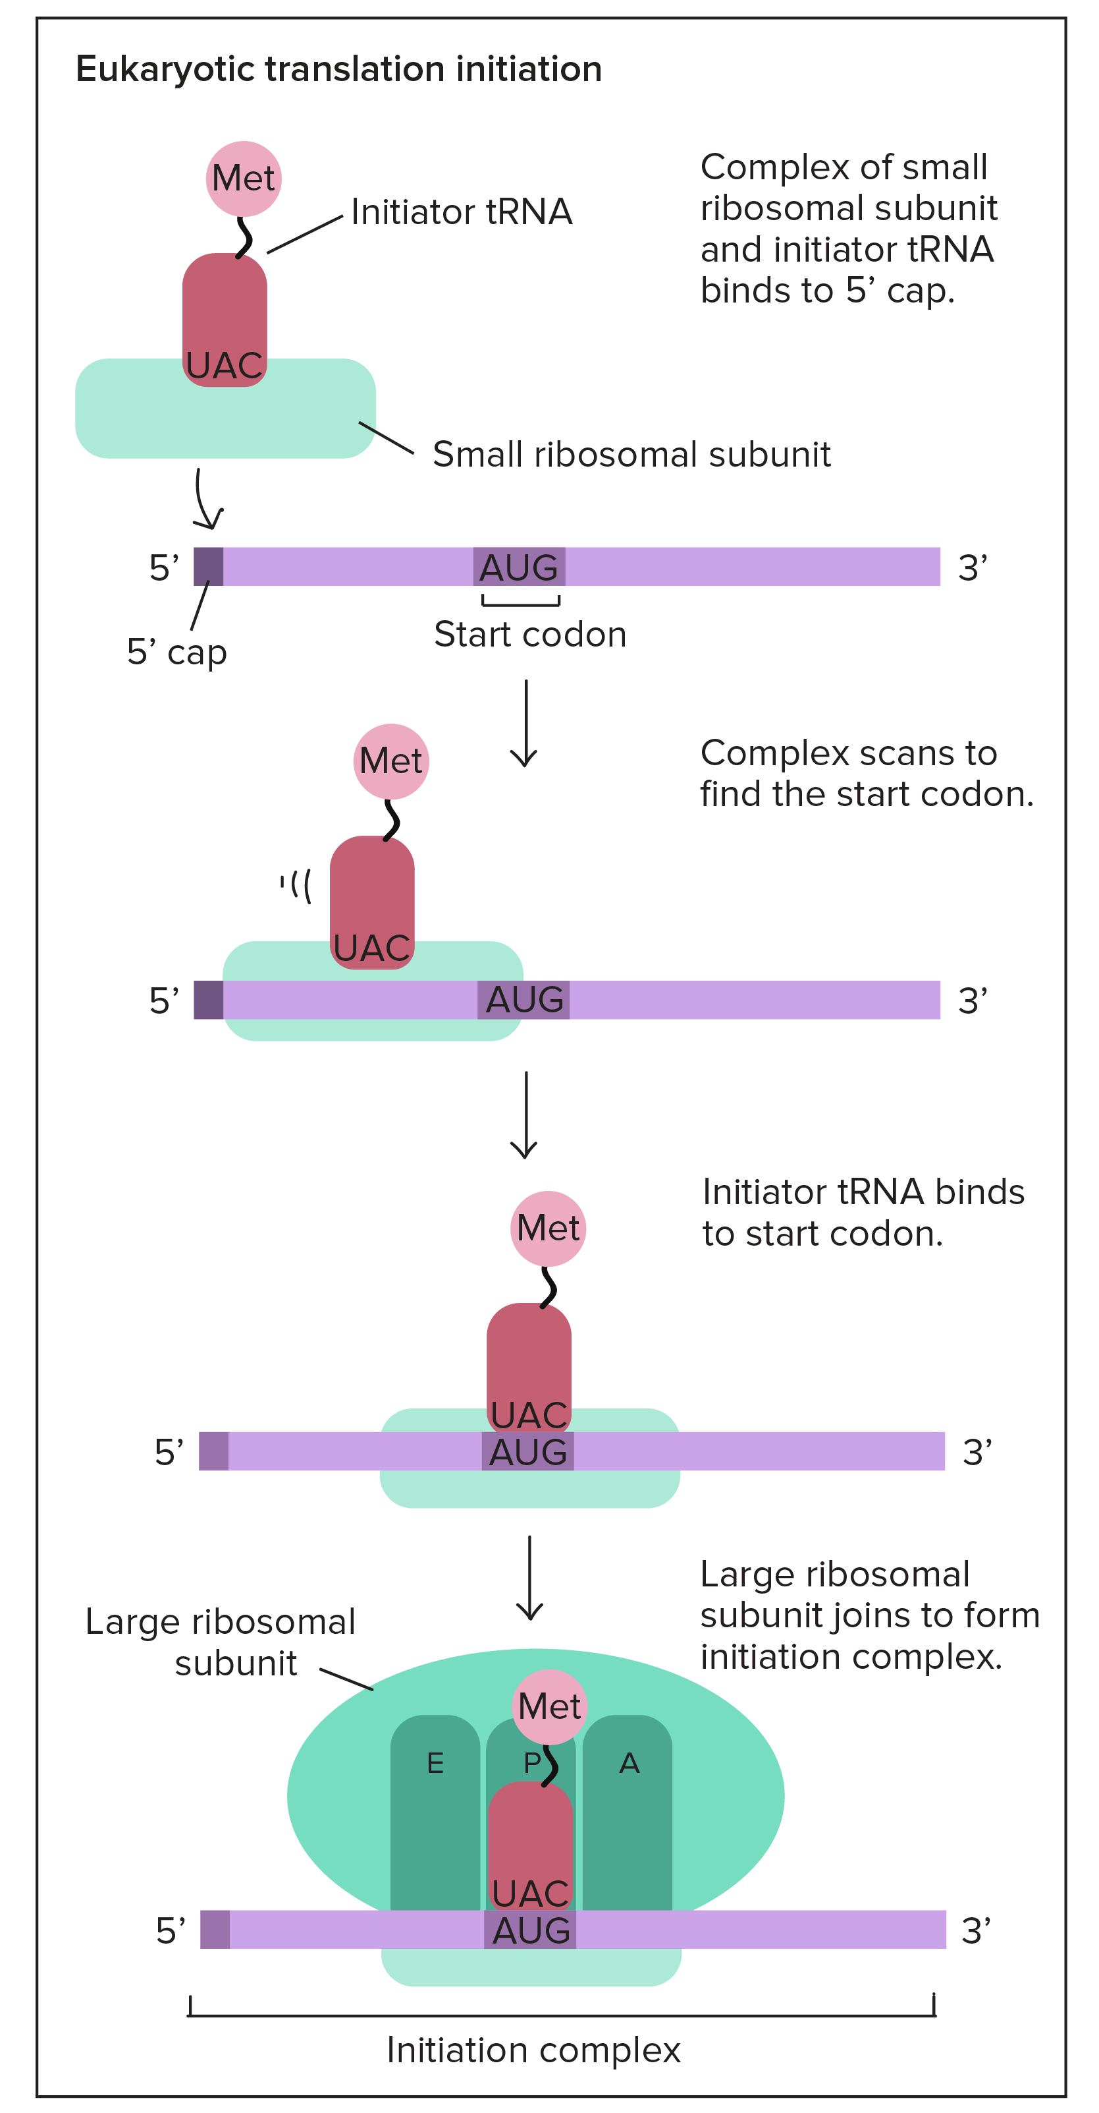

In bacteria, the situation is slightly different, in that the small ribosomal subunit doesn't start at the 5' end of the mRNA. Instead, it attaches directly to certain sequences in the mRNA. These sequences, called **Shine-Dalgarno**sequences, come just before start codons and essentially "point them out" to the ribosome.

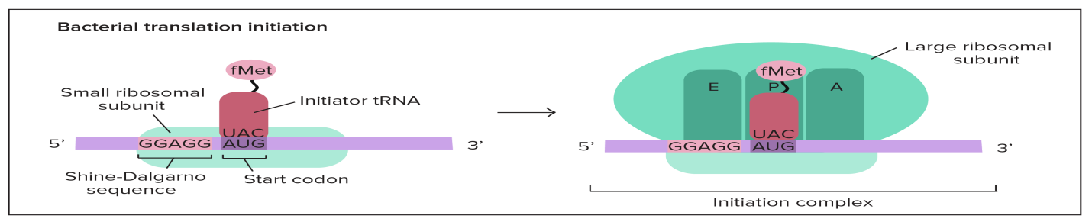

What's the point of Shine-Dalgarno sequences? Bacterial genes are often transcribed in groups (called operons), so one bacterial mRNA can contain the coding sequences for several genes. A Shine-Dalgarno sequence marks the start of each coding sequence, letting the ribosome find the right start codon for each gene.

## Stage 2: Elongation

Once the initiation complex has formed, it's time to move on on to the next stage of translation: elongation. I like to remember what happens in this stage by using its handy, descriptive name: e**long**ation is when the polypeptide chain gets **long**er.

To get a feel for elongation, let's take a look at the first round of elongation—after the initiation complex has formed, but before any amino acids have been linked together to make a chain.

Our first, methionine-carrying tRNA starts out in the middle slot of the ribosome, called the P site. Next to it, the neighboring codon is exposed in another slot, called the A site. The A site will be the landing site for the next tRNA, one whose anticodon is a perfect (complementary) match for the exposed codon.

Non-matching tRNAs may also enter the A site. Why doesn't this cause wrong amino acids to be added to the chain? In one of my favorite cool facts about translation, only a tRNA that's a perfect match for the codon will be "released" there by its helper proteins (in a. This matchmaking process is called codon recognition.

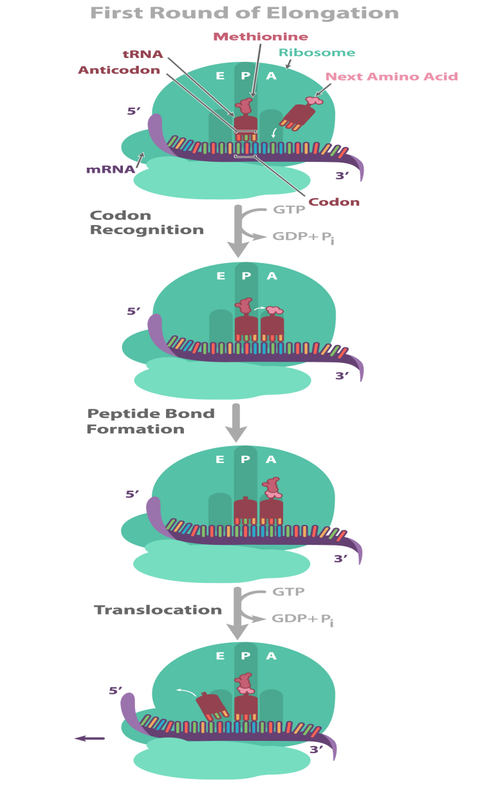

Elongation proceeds in three steps: codon recognition, peptide bond formation, and translocation. Let’s walk through each of these steps, starting with the first round of elongation that takes place after the initiation complex has formed.

In elongation, the ribosome moves along the mRNA in the 5’ to 3’ direction. As it moves, tRNAs bind to the codons of the mRNA and add their amino acids one-by-one to the C-terminus (carboxyl group end) of the growing polypeptide.

**Step 1: Codon recognition.** Once the ribosome is fully assembled, the first (start) codon, bound to a tRNA carrying methionine, is positioned in the P site. The second codon lies in the neighboring A site, where it can bind to an incoming tRNA that has a complementary anticodon (and thus bears the amino acid specified by the codon). tRNAs are carried to the ribosome by proteins called **elongation factors**, which will release a tRNA only if its anticodon correctly matches up with the codon in the A site. Elongation factors release matching tRNAs in a process that involves GTP hydrolysis, so GTP serves as an energy source for this specific matching.

**Step 2: Peptide bond formation.** The large ribosomal subunit catalyzes the formation of a peptide bond between the incoming amino acid (attached to the tRNA in the A site) and the last amino acid in the existing chain (attached to the tRNA in the P site). Specifically, the peptide bond forms between the amino group of the incoming amino acid and the carboxyl group of the last amino acid in the chain. In the first round of elongation, the chain is only one amino acid long, so its first and last amino acid is methionine. Peptide bond formation links methionine to the second amino acid in the chain, such that the tRNA in the A site carries a chain of two amino acids.

**Step 3: Translocation.** Once a peptide bond has formed, the ribosome moves in the 5’ direction, shifting one codon down on the mRNA. This action shifts (translocates) the tRNA carrying the polypeptide from the A site to the P site. At the same time, the empty tRNA in the P site moves to the E site, where it is released into the cytoplasm. This step involves another elongation factor, which also uses GTP as an energy source. Translocation exposes the next codon of the mRNA sequence in the A site, allowing another tRNA to bind so the cycle can begin again.

During elongation, the polypeptide grows as these three steps are repeated over and over. In the example above, we saw how the first amino acid (methionine) is linked to an incoming amino acid. As each new tRNA binds at the A site, a peptide bond forms and a new amino acid is added to the growing polypeptide.

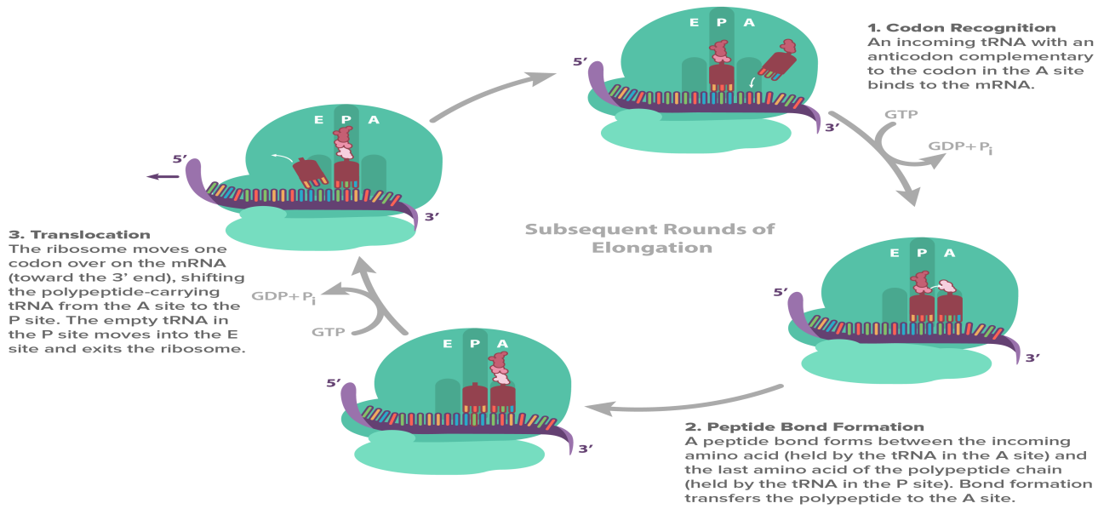

When the entire coding sequence of the mRNA has been read, a stop codon will enter the A site of the ribosome, signaling that the polypeptide is finished and must be released. Let’s have a look at this final stage of translation, known as termination.

## Stage 3: Termination

As its name suggests, termination is the stage in which translation ends and the completed polypeptide is released. Termination occurs when a stop codon (UAG, UAA, or UGA) enters the A site of the ribosome and a protein called a**release factor** binds to it. The release factor is not a tRNA, but it has a similar shape to a tRNA, allowing it to fit into the A site. The binding of the release factor causes a water molecule to be added to the end of the polypeptide (in place of an amino acid), breaking the bond that connects it to the tRNA in the P site. The released polypeptide then exits through a tunnel in the large ribosomal subunit^2​2​​start superscript, 2, end superscript.

After the polypeptide is released, the translation machinery comes apart into its individual components. This step requires the help of special proteins and, like other steps of translation, expends energy in the form of GTP^2​2​​start superscript, 2, end superscript. The ribosomal subunits, tRNAs, and mRNA remain in the cytoplasm and may participate in additional rounds of protein synthesis (although the tRNAs must be re-charged, and the mRNA will break down after some number of uses).

## Differences between bacteria and eukaryotes

Above, we discussed a few differences between bacteria and eukaryotes at the initiation stage of translation. In the section below, we'll review these differences in initiation and cover some other differences in the translation process between bacteria and eukaryotes.

### Coupling of transcription and translation

Because bacterial cells lack a nucleus, transcription and translation take place in the cytoplasm, meaning that they can be **coupled**. That is, portions of an mRNA that have been transcribed can start being translated even before the entire mRNA is completed. This coupling is not possible in eukaryotic cells because transcription and translation are physically separated inside the cell: transcription takes place in the nucleus, while translation occurs in the cytoplasm. Thus, in eukaryotes, an mRNA must be completely transcribed (and exported from the nucleus) before it can be translated. Eukaryotic mRNAs must also be spliced and modified in the nucleus before they are ready for translation.

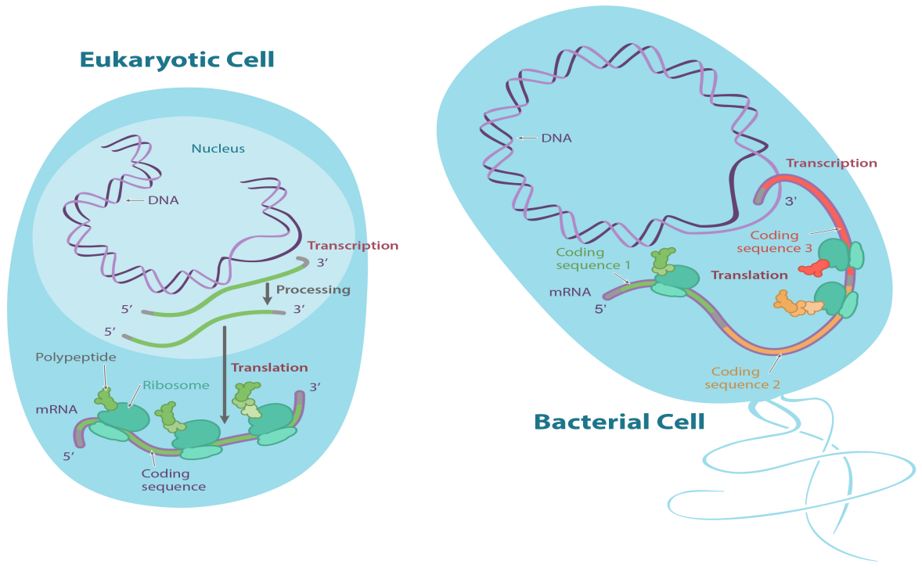

### Single genes vs. operons

Another difference between bacteria and eukaryotes is the number of polypeptides an mRNA molecule typically encodes. Many bacterial genes are found in **operons**, clusters of related genes that are transcribed from a single promoter to produce a single mRNA. Thus, bacterial mRNAs often contain multiple coding sequences, each encoding its own polypeptide and beginning with its own start codon. To ensure that all of the coding sequences in an mRNA are translated, bacterial mRNAs typically contain Shine-Dalgarno sequences, which direct the ribosome to each start codon. (See the section on translation initiation for more details.) In contrast, most eukaryotic genes have their own individual promoters, so mRNA molecules in eukaryotes typically contain just one coding sequence that encodes a single polypeptide.

## Polyribosomes

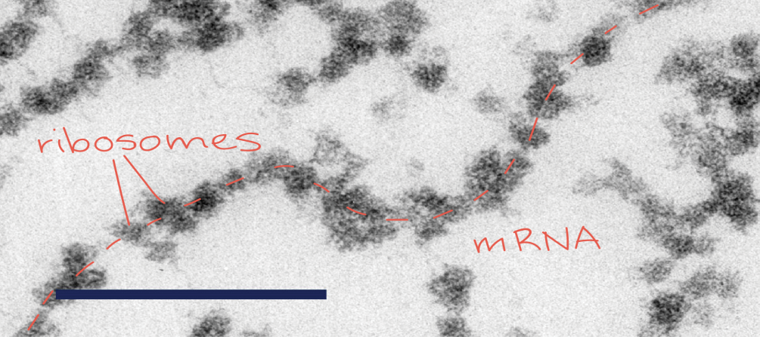

As shown in the diagram above, mRNAs from both eukaryotes and bacteria may be translated by multiple ribosomes at the same time. Each ribosome binds at a start codon, but once it has moved far enough down the mRNA, another ribosome can bind to the same start codon and begin translating. These groups of ribosomes translating a single mRNA resemble beads on a string and are known as **polyribosomes**. The translation of an mRNA by multiple ribosomes in a polyribosome allows many copies of the polypeptide to be produced in a short period of time. The high-magnification microscope image at right shows examples of polyribosomes from a rat.

From polypeptides to functional proteins

Just because a polypeptide has all its amino acids doesn’t necessarily mean it’s ready to do its job. Instead, a polypeptide may need to go through some additional steps following translation in order to become a functional protein (or subunit of a larger protein).

### Protein folding

First, the polypeptide chain must fold into its correct three-dimensional structure, which is crucial to its function. A polypeptide takes on its three-dimensional shape through hydrogen bonding and other interactions between the amino acids that make it up. You can read more about this process in the article on [orders of protein structure](https://www.khanacademy.org/science/biology/macromolecules/proteins-and-amino-acids/a/orders-of-protein-structure). Sometimes, two or more polypeptides that are made separately come together to form a single, functional protein. Proteins like this, which are made up of multiple subunits, are said to have **quaternary structure**.

In some cases, a polypeptide will fold spontaneously into its correct shape in the part of the cell where it’s made. In other cases, polypeptides may need special conditions, sometimes provided by helper proteins called **chaperones**, in order to take on their correct structure.

### Post-translational modifications

Polypeptides may also undergo a variety of chemical and structural alterations, collectively known as **post-translational modifications**. In some cases, these modifications take place dynamically during the life of a protein, regulating its activity (i.e., turning it “on” or “off”). In other cases, the modifications may simply be part of the protein’s standard maturation process in the cell and may be required for it to function.

In some forms of post-translational modification, a polypeptide may have amino acids snipped off at its end, or may even be chopped up into multiple chains. These processes are known **proteolytic cleavage**. In other cases, certain chemical groups may be added to the protein. For instance, carbohydrate groups are added in a process called **glycosylation**, and phosphate groups are added in a process called **phosphorylation**. These modifications can alter the structure of a protein or its interactions with other molecules, thus affecting its function.

### Protein targeting

In addition to undergoing post-translational modifications, polypeptides must be shipped to the correct part of the cell in order to perform their jobs. Some polypeptides contain amino acid sequences that act as a "address labels" directing them to a specific organelle or compartment. For instance, some polypeptides contain a sequence called a **signal peptide**, which causes them to enter the [secretory pathway](https://www.khanacademy.org/science/biology/structure-of-a-cell/tour-of-organelles/a/the-endomembrane-system) during translation. Other polypeptides contain signals that direct them to the chloroplast, mitochondrion, peroxisome, or nucleus. For more information about how proteins are sent to different locations inside and outside the cell, check out the article on [protein targeting](https://www.khanacademy.org/prometheus/biochemistry-and-cell-biology-staging/introduction-to-translation/a/protein-targeting).